Diamond View Middle School

Student Handbook
2022-2023
Diamond View Middle School
850 Richmond Road
Susanville, CA 96130
530-257-5144
Mrs. Dede Heimbigner, Principal

www.diamondviewschool.org
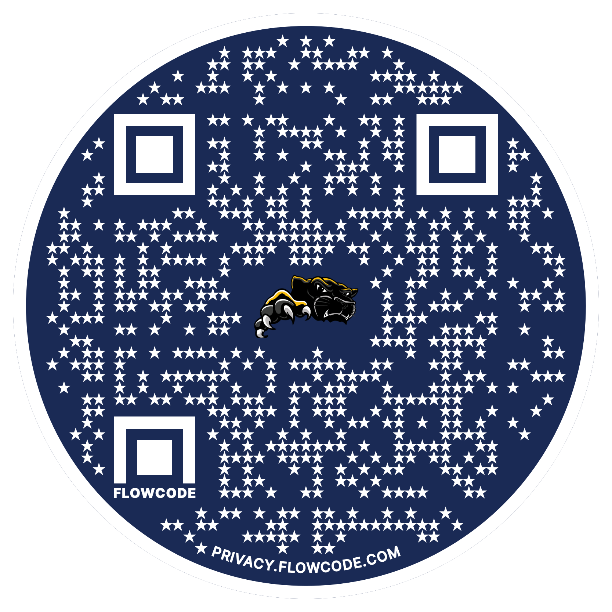

People to know at Diamond View School
Office
Name | Position | E-mail | Extension | Room
Dede Heimbigner | Principal | dheimbigner@susanvillesd.org | 4105 | Office
Jaime Haynes | Administrative Assistant | jwright@susanvillesd.org | 4101 | Office
Ashley Woodbury | Secretary | jhaynes@susanvillesd.org | 4102 | Office
Julie Galindo | Health Clerk | jgalindo@susanvillesd.org | 4103 | Office
Teachers
Sarah McIntyre | ELA/SS 6th | smcintyre@susanvillesd.org | 4130 | 210
Jennifer Smith | Math 7th , 8th | jsmith@susanvillesd.org | 4119 | 108
DJ Jenner | Math/ Science 6th | djenner@susanvillesd.org | 4129 | 209
Daniel Hartrum | PE | dhartrum@susanvillesd.org | 4134 | Girls Gym
Mike West | ELA/SS 8th | mwest@susanvillesd.org | 4116 | 106
Salome Shaw | EL | sshaw@susanvillesd.org | 4135 | DV-208
Robert Gammie | Special Education | rgammie@susanvillesd.org | 4111 | 101
Susan George | Special Education | sgeorge@susanvillesd.org | 4111 | 400
Rene Adams | Science 7th & 8th | radams@susanvillesd.org | 4131 | 211
Cyndy Martin | Math Support | cmartin@susanvillesd.org | 4121 | 103
Natalie Loiler | Math/Science 7th | nloiler@susanvillesd.org | 4124 | 204
Tara Nielsen | ELA/SS 8th | tnielsen@susanvillesd.org | 4119 | 108
Cory Young | Math/Science 6th | cyoung@susanvillesd.org | 4122 | 202
Rochelle Nakanishi | ELA/SS 7th | rnakanishi@susanvillesd.org | 4118 | 109
Amanda Ratcliff | ELA/SS 7th | aratcliff@susanvillesd.org | 4114 | 104
Cassie West | ELA/SS 6th | cwest@susanvillesd.org | 4123 | 203
Donna Mohr | Math 8th | dmohr@susanvillesd.org | 4132 | 212
Support Staff
Illia Perkins | Librarian | iperkins@susanvillesd.org | 4133 | 200
Brenda Moran | Paraprofessional | bmoran@susanvillesd.org
Kayla Pacheco | Food Service | kpacheco@susanvillesd.org | 4107 | Kitchen
Maira Velasquez | Title VI Coordinator | mvalasquez@susanvillesd.org | 4022 | 201
Tosh Sandei | Day Custodian | tsandei@susanvillesd.org
Tyler Bayles | Night Custodian | tbayles@susanvillesd.org
Maria Tristan | Paraprofessional | mtristan@susanvillesd.org | 4060 | 208
Kathy Matthews | Cafeteria Staff | kmathews@susanvillesd.org | 4107 | Kitchen
David Zavala | Tech. Specialist | dzavala@susanvillesd.org | 4134 | 402
Jen Ormachea | Cafeteria | jormachea@susanvillesd.org | 4107 | Kitchen

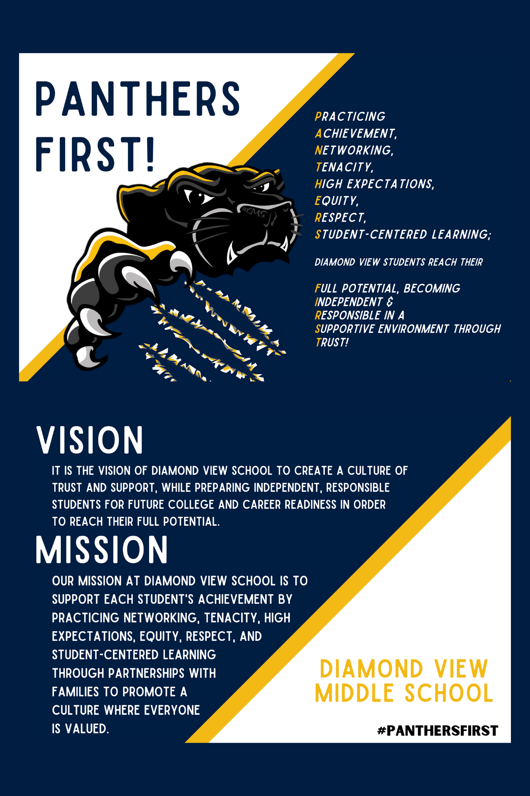

Diamond View Bell Schedule
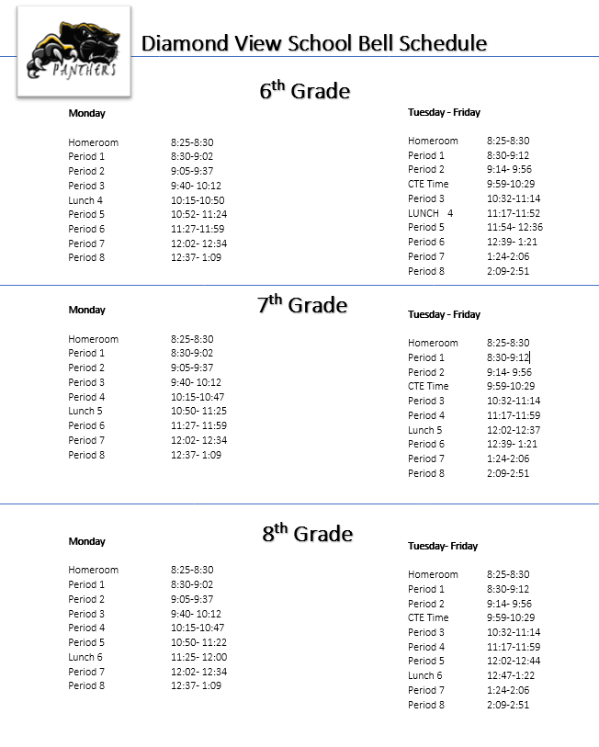

Diamond View also uses social media to stay connected:
Facebook- @diamondviewmiddleschool
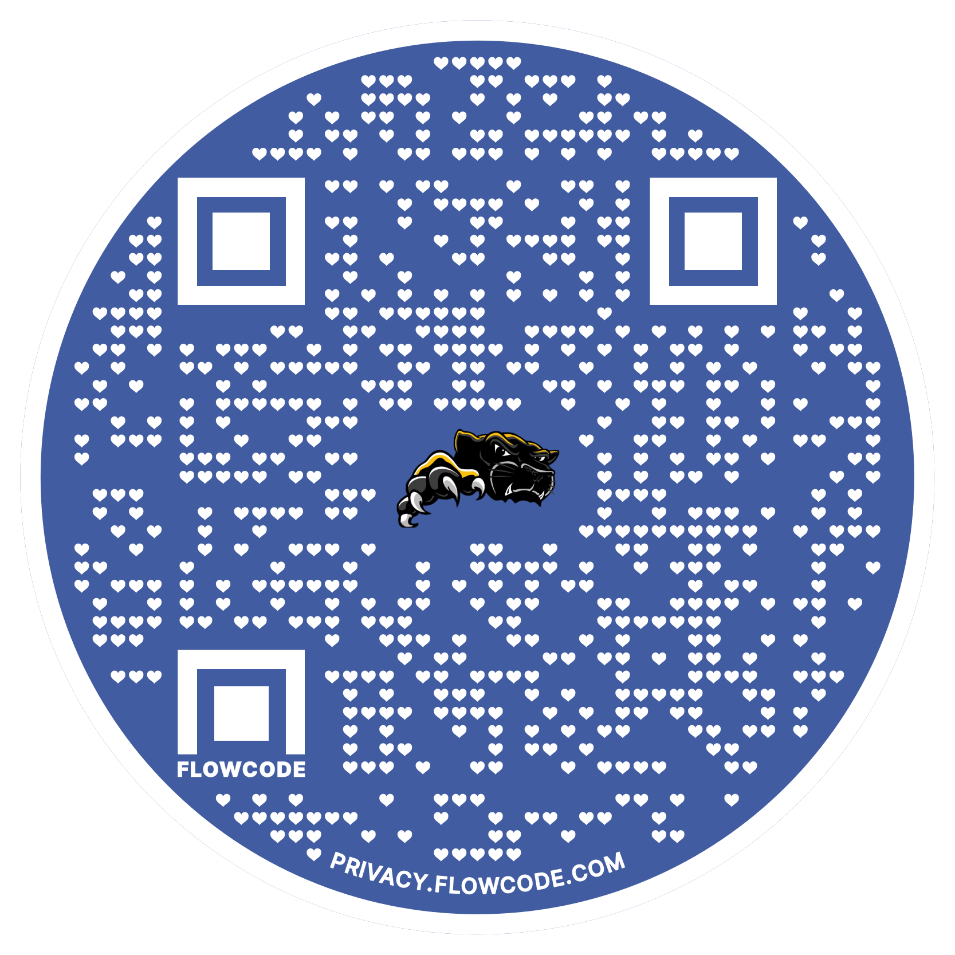
GENERAL INFORMATION

Announcements

The daily bulletin is read every day at the beginning of homeroom to students. In addition, it is posted on the DV website for student, parent, and staff viewing.
Diamond View School also uses the SchoolWise Parent Alert system which includes automated voice, email and text messaging that helps facilitate communication between school and home. This system may be used to notify all parents in the event of an emergency, so it is important to notify the school of phone number changes.

Attendance

Students and parents are responsible for individual attendance. To report an absence, please call 257-5144. Students will be recognized for perfect attendance each trimester. Perfect attendance does include being marked tardy.
Absence from School
When a student returns to school following an absence of any kind, a phone call (257-5144), email jormachea@susanvillesd.org or note from a parent or guardian that states the reason for the absence is required. A student’s absence may only be cleared by a parent/guardian within 48 hours of the absence. After this period, an absence cannot be cleared and can affect a student’s overall grade in a class and participation in extra-curricular activities. Absences not cleared by the parent/guardian within 48 hours of the absence will be considered a permanent cut/truancy absence and labels in SchoolWise as a “T” standing for truant. This policy applies to tardies as well.
Students are not eligible to participate in any extra-curricular activities (e.g. sports, dances, clubs) on days in which they are absent.

Diamond View School works with the Lassen County Probation Department’s truancy officers to ensure that students and parents understand the importance of daily attendance.
According to California Education Code excused absences are limited to the following reasons:
- Personal Illness- more than 3 days requires a doctor’s verification
- Funeral services for student’s immediately family
- Medical appointments
- Court appearance for the student
- Quarantine of student or family
- Observing a religious holiday

*When a student has had 14 absences in the school year for illness verified by a doctor’s note, or parent note, any further absences for illness MUST be verified by a physician to be excused.

Bicycles, Scooters, Skateboards
Any student riding a bicycle, scooter, or skateboard to school is responsible for placing it in the rack or skateboard box. The school will not assume the responsibility for bicycles, scooters, or skateboards. Students are not to ride bicycles, scooters, and skateboards on the school campus. Student bicycle riders must observe helmet laws and the same laws that govern automobiles.

Bus Passes
Students must obtain a bus pass in the school office to ride the school bus. A bus pass will be provided to eligible students at the beginning of the school year. Bus transportation is provided to students who live beyond one mile from school. An application for eligibility can be obtained in the school office. Students who wish to ride the bus and get off at a stop other than their regular stop must have a note from their parent to do so.

Calendar
A Susanville School District instructional calendar can be accessed and downloaded from the Diamond View School website or in the school office. The DV homepage also includes a school calendar which lists school program and event dates.

Common Core State Standards

Diamond View School will continue implementation of the Common Core State Standards in English language arts and mathematics and has adopted and utilizes both ELA and math Common Core curriculum. Common Core State Standards were developed through a national movement to establish consistent and clear education standards for students in the United States. These learning goals help ensure that students meet college and work expectations, are prepared to succeed in a global economy and society, and are provided with rigorous content and application of higher knowledge thinking.
A database containing all California Common Core State Standards can be accessed at www.cde.ca.gov/re/cc.

Campus
There are certain areas of the campus that are off limits to students. Please be aware of the following:
- All parking lots and driveways are off limits except for loading and unloading, arriving and departing, by car or bus.
- No loitering in the front or on the sides of the campus. At the end of the day, students who are waiting for rides need to be waiting in designated places. Typically, this is by the tree on the front grass.
- Students are not allowed in any classrooms without a staff member.
- Students are not allowed in staff rooms, media rooms, storage rooms, and custodial rooms without a staff member or permission from the principal.
- During lunch and passing periods students must be in supervised areas and within direct vision of the duty supervisors.
- Students are not allowed in any area behind the computer lab building and gym.
- During lunch students are permitted to use the playground area, but are not allowed to use the upper softball fields.

Celebrations
Recognition of special events or individual students will be organized by the DV staff members as deemed appropriate. Balloons, flowers, and gifts are disruptive during instructional time. If these items are delivered to the school, students will not be permitted to retrieve them until the end of the day. Parents and students are encouraged to celebrate special occasions outside of school.

Cell Phones
Cell phones have become a way of life, a technological convenience that has impacted all of our lives in one way or another. However, in a school environment, cell phones have become a distraction, interruption, and a method of illegal exchange of information. The ringing of a cell phone during class, text-messaging, or the use of social media takes away from the valuable time needed for instruction and most importantly, student learning. Parents are to use the school’s office phone to relay any messages to students that may be urgent in nature to their child.
Therefore, cell phone use is not allowed during the school day. This includes texting, gaming, listening to music, use of a cellular data/internet connected watch, and internet use. Cell phones may be used after school for the coordination of transportation. During the school day (beginning when a student walks onto the school campus), cell phones should be powered OFF and remain inside the owner’s backpack or pocket. Headphones are also not allowed in ears or around neck and must be out of site. During PE students are expected to lock their cell phones in their PE locker. At no time should a cell phone be powered on in a restroom or locker-room. If the location of the student’s cellphone becomes an issue, it will be confiscated and kept in the office until the end of the day. On the first violation, the student may pick it up. Further violations will require a parent to pick it up. Phones will only be returned to parents or guardians.

Cell Phone Violations:
1st Offense-
-Cell phone held in office till end of day, student picks up and signs for phone, lunch
detention given.
2nd Offense-
Cell phone held in office till end of day, parent picks up and signs for phone, lunch
detention given.
3rd Offense-
Cell phone held in office till end of day, parent picks up and signs for phone, demerit
given.
Further violations will result in a conference between the student, parents and the principal and disciplinary action at the discretion of the administrator may result. If a student refuses to comply with the request to surrender their cell phone by any staff member it will be considered a cell phone offense and there will be disciplinary action.
The school assumes no responsibility for lost or stolen cell phones.
***Cell phone/headphones/tablet technology may be used under the discretion of a teacher in the classroom or library for instructional purposes.
Conferences

Parent-teacher conferences are held after the 1st and 2nd trimesters. Conferences may be scheduled during the school year at the request of parents, teachers, or the principal. Parents may make appointments with any teacher by sending them an email or phoning their classroom. Students are encouraged to participate in conferences. A staff directory with email addresses and classroom phone numbers is located in the Student Handbook, on the DV website, and in the school office.

Dances

The Student Council sponsors dances for DV students throughout the year. The Graduation Dance is for 8th graders only. Students must adhere to the following rules at dances. Students who do not follow the rules will be dismissed from the dance.
- Unacceptable behavior, including but not limited to, inappropriate dancing, touching, and signs of affection; running, yelling, and leaving the designated dance area are strictly prohibited and will lead to school discipline measures and removal from the dance.
- All school rules apply at these events.
- Students must enter the event within the first thirty minutes of the start time. Once admitted students will not be allowed to leave early unless they are being picked up by a parent.
- Students are not allowed to attend a dance if they have not attended school the day of the dance or received a demerit the day of the dance.
- Privilege to attend dances may be lost as a result of unsatisfactory conduct at school. Students with 3 or more demerits are not eligible to attend dances.
- Students must adhere to the school dress code. Disregard of the dress code will result in dismissal from the dance.

Dress Code

School is a place of business and students should wear clothing that is suitable for the pursuit of learning. Use common sense and do not wear clothing that is distracting, offensive, dangerous, or exposes too much skin. The staff is interested in the cleanliness and health of each student and requests that parents support our interest. As with any policy, the inclusion of all possibilities is difficult. The Diamond View staff may sometimes have to use its professional discretion regarding student dress.

Specific dress code expectations include:
Shoes: Appropriate shoes must be worn at all times. Sandals may be worn if they have a back strap and a solid sole (flip flops and shoes with foam soles are not permitted). High heels must not be more than 2 inches. Athletic cleats are not to be worn at school.
Shirts: Must not expose midriff, under garments, or cleavage. Spaghetti straps, and backless shirts are not allowed. Sleeveless shirts must cover the entire shoulder and under arm area.
Shorts & Skirts: Shorts and skirt hems (including skirt slits) must not be shorter than 4-5 inches above the top of the knee. Fingertip rules no longer apply, as arm length differs from person to person.
General Regulations:
- Ripped and torn clothing- All pants and shorts must be free of holes excessive in size. No skin to be shown any higher than 4-5” above the knee.
- Under garments must be covered at all times.
- Hats and sunglasses must be removed by both boys and girls inside the buildings.

Excessive metal accessories including chains, wallet chains, spikes, sharp protruding objects, safety pins as clothing, or other potentially dangerous items are not allowed. Bandanas and hair nets may not be worn at school.
Items directly or indirectly depicting or referring to drugs, alcohol, tobacco, vaping, violence, gangs, death, profanity, nudity, vulgarity, obscenity, scantily dressed characters, or other socially inappropriate message demeaning to any race, religion, sex, or ethnic group or which advocates the violation of the law are prohibited.
If at any time a student’s dress is such that it disrupts the educational program, the student will be required to change into appropriate attire. Students not following these guidelines will be required to immediately change clothing and will be assigned lunch detention.
- A second offense will result in a change of clothing and parent contact.
- A third offense will result in a change of clothing, detention, and a parent conference.
- Continued violations will result in further school discipline measures.

Emergency Information Forms
Parents are responsible to ensure that the school has the most recent emergency information on file. The school’s emergency forms are very important as they provide information for each child that might be needed in case of an emergency. To keep these forms up to date, we ask parents to fill out new forms at the beginning of each year. This form is sent home with students on the first day of school. Forms are also available in the school office.
This information can also be updated online at www.ssd.schoolwise.com through the parent portal.

Extra-curricular Activities
Students participating in extra-curricular activities at Diamond View School must meet the following minimum criteria:
- The student must have a grade point average of 2.0 in the previous grading period.
Grading periods are:
Trimester progress reports
Trimester report cards
2. The student must maintain a current cumulative grade point average of 2.0 to remain eligible. Eligibility will be determined at every progress report and every report card.
3. Any student who is suspended, referred to a truancy officer, or has 3 or more demerits will be ineligible to participate in the activity.
4. A student who has been referred to the alternative supervised instruction classroom, gets a demerit or is suspended from class will lose the privilege of participating in extra-curricular activities on the day of the referral.
5. Student shall be in attendance in all classes on the day of an extra-curricular event in order to participate.
Athletics
Fall Sports: Cross Country
Flag Football
Winter Sports: 7th & 8th Grade Boys’ Basketball
7th & 8th Grade Girls’ Basketball
Spring Sports: Track and Field
7th and 8th Grade Girls’ Volleyball
All Year: Drill Team
Sports physicals are required before participation in any athletics (including tryouts and open gyms). Forms are available from the Diamond View office and must be completed by the student’s parent or guardian and current medical provider.
Susanville School District is a member of the Lassen County Elementary Athletic League (LCEAL). The athletic sports program at Diamond View School is under the authority and bylaws of the LCEAL. The League Bylaws are available in the school office.
Other Extra-curricular Activities
Spelling Bee
Drama Club
School Newspaper
Yearbook
Book Club
ASB/Student Council
Geography Bowl
And more…!!

Extra-Curricular Activity Transportation Policy
Transportation of Students by Private Vehicle
There is a School Board Policy (3541.1) that addresses transportation of students by private vehicle. The Superintendent or designee may authorize the transportation of students by private vehicle when the vehicle is driven by an adult age 25 or older who possesses a valid California driver’s license or, if he/she is a nonresident on active military duty in California, possesses a valid license from his/her state of residence. To be approved, a driver shall have a good driving record and possess at least the minimum insurance require by law. Any person providing transportation to district students in a private vehicle shall register with the district for such purposes. Diamond View School requires that parent drivers have a current and complete Private Driver Application on file in the school office.
In addition, all students shall submit a Transportation Consent Form to the school employee (coach) signed by their parent granting permission for their child to ride with the specified driver to the specified event. The consent form will be provided to the driver prior to the trip, and must remain with the driver during the trip. The school employee (coach) will be responsible for ensuring that the parent drivers have the appropriate paperwork filed in the school office. The school is not liable for students who arrange rides from their personal residences. Parents who pick up students from their personal residences are responsible for making their own travel arrangements and agreements with that child’s parents.
Hall Passes
Students are required to have a hall pass when going from one location to another during class time. During lunch, students MUST have a hall pass to be in the hallway or upper restrooms. If a student is in the hallway without a pass at a time other than passing period, he/she will be issued a lunch detention. The main hallway is closed before school and during lunch.
Internet Use
Privileges: The use of information systems is a privilege, and inappropriate use will result in a cancellation of those privileges. Note: SSD filters and monitors all site-based internet activity.
Acceptable Use: The use of information systems must be in support of education and research and with the educational goals and objectives of the SSD. Use of other organization’s networks or computing resources must comply with rules appropriate to that network.
Personal Responsibility: Students will take responsibility for reporting any misuse of the network to the appropriate teacher or administrator. Misuse can come in many forms, but is commonly viewed as any message(s) sent or received that indicate or suggest pornography, unethical or illegal solicitation, racism, sexism, inappropriate language, or language that threatens, harasses, or intimidates others (cyber bullying). Use of social networking sites, blogs, wiki’s, or IM is prohibited unless directed by a teacher.
Security: If you identify a security problem, notify the system administrator at once. Never use another individual’s account. Any use identified to be a security risk will be denied access to the information system.
Vandalism: Any vandalism will result in the loss of privileges and disciplinary action. Vandalism is defined as any malicious attempt to harm or destroy data of another user, networks that are connected to the system, any hardware, equipment, wiring or software.
Teacher Responsibility: The staff will instruct the student in appropriate and acceptable use of the network and will expect students to follow protocol.
Immunizations
The California School Immunization Law requires that children be up-to-date on their immunizations (shots) to attend school. Students entering Diamond View School should have:
- 3 Hep B
- 3 Polio
- 4 DTAP
- 2 MMR
- 1 Varicella (chicken pox)
- TDAP (prior to entering 7th grade) **

**California State Law now requires that all students entering the 7th grade must have the TDAP vaccine. Incoming 7th graders will NOT be allowed to start school until the school has proof of the TDAP immunization. The State of California now only accepts a medical exemption and requires a medical exemption form to be filled out by the child’s health care provider. These forms are available in the school office.
Library
Books, internet access, and online databases are some of the resources available for student use. Students visit the library with their classes, and may use the library to read, study, and do homework. The library is open to students before and after school from 7:30am-4pm, and most days during lunch to allow students the opportunity to complete assignments. Students typically go to the library one period per week with their core classes. A limited number of books may be checked out for 2 weeks. Students with overdue books will be restricted from using the library until they are returned or paid for. Overdue lists are made available to students weekly when they visit the library with their class. Appropriate library behavior is expected at all times. No eating or drinking is allowed in the library. Not following library rules will result in suspension from the library and school discipline consequences. Students are responsible for replacement costs if materials are lost or damaged. Other library services will be discussed during library orientation.
Lost and Found
The Lost and Found is located on the patio. Students may report a missing item in the school office so that should the item be found, it can be returned to the owner. Once a month, unclaimed articles of clothing are donated to a local charity. Small valuables should be turned into the main office.
Mealtime Information
The Susanville School District provides breakfast and lunch services at Diamond View. Students, who wish to participate in the USDA Federal Free and Reduced lunch program, can pick up a form in the office for their parent/guardian to fill out. These forms are included in the beginning of the year packets, and must be completed each school year. Lunch money (cash or checks) will be accepted in the office. Current meal prices are $2.85 for lunch, $0.40 for reduced price lunch, $1.50 for breakfast and $0.30 for reduced price breakfast.
Lunch
- Food at lunch must be eaten in the cafeteria. Food may not be taken to the playground area. Violation of this rule will result in a lunch detention.
- Eating areas must be cleared and trash must be placed in trash cans before students leave their table.
- Taking food from others is not allowed.
- Throwing food or trash in the cafeteria or on the patio is strictly prohibited. This will result in demerits, campus clean-up, and possible suspension.
- Students who are eating in the cafeteria must line up with the class that they just attended. Line cutting and crowding into the lunch line is not allowed.
- Students must be seated at a table during lunch.
- When students are finished eating they will go to the playground.

The lunch program form can be completed online at www.ssd.schoolwise.com through the parent portal.

Medication
Students must leave all medications in the office including non-prescription medicine such as Tylenol and Ibuprofen. All medications, including non-prescription medicine, must have parental and physician authorization in writing. Forms for this procedure are available in the office.
Messages to Students
If a parent has an emergency message to give their student, they may call the office, and the office staff will see that the student gets the message. Phone calls will not be transferred to classes during class time to avoid interruptions during instruction. If a message is left for a student, the student will get it during passing period.
Electronic Items/Nuisance Items
Any items that are disruptive to the educational process will be taken away and kept in the office until the student or parent picks it up. Radios, laser pointers, electronic games, cameras, camcorders, etc. are not allowed at school. Electronics must be powered OFF and remain inside the owner’s backpack during the school day. The same rules that apply to cell phones apply to electronic devices. Headphones must remain unplugged and/or disconnected and inside the owner’s backpack during the school day.
The school assumes NO responsibility for lost or stolen personal property.
Please note that laptop computers, tablets, and electronic book readers are to be used for educational purposes only as prescribed by the classroom teacher. Using these items for social networking, gaming, surfing the internet, emailing is not allowed and may result in having the device confiscated. If you have a question about appropriate use, please ask a staff member.
Health Clerk
Students who do not feel well enough to remain in class may come to the office only after obtaining a teacher’s permission. The health clerk office is for illness or injury only. For minor illnesses or injuries, students will be required to return to class within the class period. Every effort will be made to communicate with parents. Under no circumstances may a student leave school without being signed out in the office.

COVID Precautions
Diamond View School will follow guidelines set by the Susanville School District regarding masks COVID precautions. Please visit the Susanville School District website for current guidelines. http://www.susanvillesd.org
Office Hours
The Diamond View School office is open between the hours of 7:30 a.m. and 3:45 p.m.

Permits to Leave School
When students need to leave school early, a parent must come into the office to sign the student out. Students are not to leave the school grounds at any time during the school day unless permission has been obtained by the principal or designated office staff. Students may not leave campus during lunch.

Personal Property
Students assume responsibility for their personal property. The school is not responsible for the loss or theft of personal property. Large amounts of cash and electronic devices should be left at home.

School Safety/Security
Student safety is the school community’s highest priority. To enhance school safety and campus security, video surveillance cameras are installed in public areas throughout the campus. Ample supervision is provided during lunch and passing periods. Trained supervisors help to ensure that students are safe and accountable during lunch. The school works in partnership with local agencies to continuously improve upon emergency preparedness measures.

Scented Products
Personal products with strong scents should not be used in excess as strong fragrances may disrupt the learning environment. Deliberate use will result in confiscation and disciplinary action.

School Hours
School hours are from 8:00am to 2:11pm. The first warning bell rings at 7:57am. Students may arrive on campus one-half hour prior to the start of school. Students are to report to the multipurpose room to eat breakfast or the playground area in the back of the school. Students may not hang out in the front of the school.
Sexual Harassment Policy
Prohibited sexual harassment includes, but is not limited to, unwelcome sexual advances, unwanted requests for sexual favors or other unwanted verbal, visual or physical conduct of a sexual nature made against another person of the same or opposite gender, in the educational setting, when: (Ed Code 212.5; 5 CCR 4916) the conduct has the purpose or effect of having a negative impact on the student’s academic performance, or of creating and intimidating, hostile or offensive educational environment.
The following behaviors are prohibited in the Susanville School District:
- Unwelcome leering, sexual flirtations or propositions.
- Sexual slurs, epithets, threats, verbal abuse, derogatory comments or sexually degrading descriptions.
- Graphic verbal comments about an individual’s body, or overly personal conversation.
- Sexual jokes, notes, stories, drawing, pictures, or gestures.
- Spreading sexual rumors.
- Teasing or sexual remarks about students enrolled in a predominantly single gender class.
- Massaging, grabbing, fondling, stroking, or brushing the body.
- Touching an individual’s body or clothes in a sexual way.
- Purposefully cornering or blocking normal movements.
- Displaying sexually suggestive objects.

Student Council (ASB)
The Student Council is the governing body, elected by the student body, which provides the leadership and direction for student activities during the school year. It works in close cooperation with the faculty advisor to plan, organize, facilitate, and lead student activities and projects.
Student Study Team (SST)
At Diamond View School, our goal is to help all students learn and achieve to their fullest potential. To help us reach this goal, we have a Student Study Team made up of regular classroom teachers, the resource teacher, the school psychologist, and the principal. The purpose of this team is to help teachers and administrators address educational and/or behavioral concerns they may have regarding a student and to explore possible solutions to help the student succeed in school.
Technology
Computer lab-
The computer lab is open daily from 8:05am-3:45pm. Students may access the lab to do research and complete class assignments. The computer lab specialist is available during these hours to assist students with their assignments. Each core class will also visit the computer lab once per week and all students will receive technology instruction once a week through their EI period. Misuse of the computer lab or the technology in there will result in suspension from the computer lab.

Chrome books-
The school has a number of chrome carts available for check out and instructional use by the teachers. They are used for a variety of educational activities and instruction. Students are taught and modeled appropriate behaviors and expectations for chrome book use and expected to follow them. The chrome books are a valuable tool to bring twenty-first century learning skills into the classrooms. Students are responsible for the chrome books while in use and will be held liable for any damage that occurs. Diamond View also has a limited amount of Chromebook available for student use at home. If you would like to check one out for the school year, please check with the front office.

Telephone Use

Student use of the school office telephone is restricted and requires a pass from a staff member. Students who become ill during the day must report to the Health Clerk who will make arrangements should they need to go home. After school, the office phone may not be used for 15 minutes after the final bell. Students need to make after school arrangements before coming to school.

Textbooks
In some classes, students will be checked out a textbook including a cover that may be left at home for homework. At the end of the year, the book and cover are to be returned in good condition. Students will be held accountable for lost or damaged books and covers. Students can access their math and English language arts books online. All teachers will provide online access information to students.

Visitors on Campus

In an effort to maintain the integrity of the learning environment and the security of our campus, Diamond View School would like to remind parents of the current policy regarding visits to the classrooms as outlined in Board Policy 1250, Community Relations and Administrative Regulation 616, Classroom Interruptions. We encourage parent participation on campus and in our classrooms and would like to remind parents that visitations to the classroom and/or observations are to be made through an advanced appointment with the teacher and principal.
As part of your visit or observation, we ask that you abide by the following conditions:
Be a silent observer;
Turn your cell phone off;
Stay within the agreed-to times;
Keeps observations confidential; and,
No recording or video-taping.

Violation of these conditions may result in you being asked to leave the campus.
Please remember that the exception to the advance notice policy would be field trips, special events, having lunch with your child in the cafeteria, and regular classroom volunteers. Additionally, per testing guidelines, we cannot allow any classroom visits during state mandated testing (CAASPP, ELPAC, etc...)
Diamond View School welcomes and encourages parents to come to school and be a part of your child’s education. We also ask that you be respectful of the education of all students and help us by giving prior notice.

Website
The Diamond View School website can be accessed through the Susanville School District webpage at www.susanvillesd.org or directly at www.diamondviewschool.org. The school website is updated regularly and contains useful information including the student handbook, class information, upcoming events, the daily bulletin, and more. Please check the website regularly to stay informed.
Weather
In case of very bad weather, an announcement will be made during recess to have all students report to the gym. Students should come prepared for the weather. On days with light rain or snow and wind, students will likely be outdoors after eating lunch.

EMERGENCY INFORMATION
Emergency Procedures
In case of an emergency, it is the intention of the school to respond in a manner that ensures student safety. If necessary, students will remain at school until parents are notified of the emergency and procedures for safe dismissal of students. The SchoolWise Parent Alert messaging system and local radio announcements may be used to notify parents in the event of an emergency.
Emergency drills will be held throughout the year to ensure that students and staff are familiar with emergency protocol. Fire drills will be held on a monthly basis. Diamond View works in conjunction with local emergency response agencies to ensure school safety. A detailed school emergency plan including specific procedures and exit routes are posted in each room of the school building.
The school’s Comprehensive Safety Plan can be viewed in the office.

School Emergency Codes
Code Yellow – EVACUATE
Bomb Threat, Fire, Post Earthquake, Etc.

Code Green – DUCK AND COVER
Earthquake

Code Blue – SCHOOL ALERT
Dangerous situation in community or injury in room

Code Red – LOCK-DOWN
Armed Intruder, Shooting Hostage, Violent Activity

PHYSICAL EDUCATION
Curriculum
The physical education program for students in grade six through eight provides the opportunity to expand the student’s performance and understanding of fundamental movement and motor skills to more specialized movement and motor skills used in a variety of content areas. The physical education classes are standards based with a focus on health and fitness.
Requirements
Seventh and eighth grade students have P.E. every day. Sixth grade students have P.E. four days a week. All students are required to wear physical education uniforms, socks, and closed-toed, rubber soled athletic shoes to class each day. The P.E. uniform consists of athletic shorts or sweats, t-shirt or sweatshirt, and shoes with laces that tie, preferably tennis shoes. Any variation from this dress code must be approved by the PE teacher. Panther P.E. uniforms will be sold throughout the year online.
Participation
All students must participate in physical education. Participation consists of dressing out, being an active participant in all activities, and following class rules. Students who are to be excused from physical activities for more than three days or who require a limited P.E. program must have a note verified by a doctor. Students not actively participating in P.E. will complete alternative assignments.
Students receive credit for each day they attend and participate in class. It is the student’s responsibility to obtain and complete the teacher’s designated make-up assignment within one week of the absence.
Locker Rooms
Students will be issued a lock and P.E. locker. Personally owned locks are not permitted and will be cut off if used. Students will be charged $11.50 for lost P.E. locks. Students are responsible to keep lockers locked at all times to prevent loss and theft. The school assumes NO responsibility for lost or stolen personal property. Students are allowed in the locker room only when supervised.

ACADEMIC POLICIES
Homework
Homework contributes to building responsibility, self-discipline and life-long learning habits. Time spent on homework directly influences a student’s ability to meet academic standards. It is expected that homework assignments will be relevant, challenging, meaningful, and that they reinforce classroom learning objectives. Homework assignments should be an extension of classroom learning and will provide students an opportunity for independent practice. When students repeatedly fail to do their homework, parents shall be notified and asked to contact the teacher. DV teachers will provide information about their individual homework policies. Each teacher has his/her own webpage on the Diamond View School website. Class assignments are posted weekly.
Honor Roll
All students are eligible for Honor Roll if they receive at least a 3.00 grade point based on their trimester grades. Principal’s Honor Roll, will be awarded to students who receive a 4.0 grade point average and maintain straight A’s. Students who earn Honor Roll every trimester will be invited to attend a special recognition trip at the end of year.

Grades and Report Cards ADD CALCULATION GPA

Student grades will be updated regularly. Student progress can be accessed via SchoolWise Gradebook which is an online grading program that allows students and parents to access grades at any time. Each student and parent will be provided with a password and further information regarding this service. In addition, progress reports including progress towards academic standards will be provided mid-trimester.
Students will receive three report cards during the year. A report card will be provided after each trimester. Diamond View School holds school wide parent conferences at the end of the 1st and 2nd trimesters. Students are encouraged to participate in conferences. Please refer to the school calendar for the dates of trimester conferencing.
A – Superior
B – Above Average
C – Average
D – Below Average
F – Failing

In addition, the following grades may be used for special circumstances:
INC – Unfinished work required by the teacher, must be completed before a grade is issued.
NG – No grade, not enrolled at Diamond View long enough to earn credit.

GPA is calculated by averaging course grades. Please remember that Math and ELA are double core periods, so their points are doubled. Points are issued to letter grades as A-4, B-3, C-2, D-1, F-0

For Example – A sample report card

Period | Class | Grade | Calculation | Points
1 -2 | Math | B | 3 points x 2 periods | 6
3-4 | ELA | C | 2 points x 2 periods | 4
5 | Science | A | 4 points x 1 period | 4
6 | Social Studies | D | 1 points x 1 period | 1
7 | PE | B | 3 point x 1 period | 3
 |  | Overall GPA Average | Add up all points and divide by 7 periods  18/7 | 2.57 GPA

Make-up Work
Students who miss work because of an excused absence shall receive full credit for work that is turned in according to a reasonable make-up schedule. Teachers shall assign such makeup work as necessary to ensure academic progress, not as a punitive measure. Please check the school website for missing work, email your child’s teachers or call the school office and leave a message to get missing assignments after two or more days of absence.

Graduation Requirements

Participation in the 8th grade graduation ceremony is an opportunity and privilege reserved for those students who have worked hard to pass academic standards and have complied with behavior standards set forth by the Susanville School District, the California Education Code, and Diamond View School.
The requirements are:
- Students must have a cumulative grade point average of 2.0 or above from the eighth grade.
- Students must have less than 3 demerits.
- Students must have been continuously enrolled at Diamond View School for the entire third trimester.
- Students must have passed the United States Constitution Test.

STUDENT BEHAVIOR
Expectations
The Diamond View School community is committed to providing a safe, orderly environment for student learning and growth. Rules and high expectations for conduct are clearly communicated and consistently enforced. The school staff expects students to observe school rules, demonstrate cooperation, and exhibit good conduct and common courtesy at school and at all school-sponsored events. It is the right and responsibility of every DV student to attend their classes, complete assignments and receive academic credit for their efforts and achievement. School rules apply (1) while on school grounds, (2) while going to and from school, and (3) during, or while going to or coming from a school sponsored activity.
Positive Referral slips.
Positive Referral slips are given to students as a positive recognition for good citizenship. Merit slips will be issued at the discretion of staff members and are redeemable for rewards.

Recognition of Citizenship
Students who demonstrate good citizenship will be rewarded with various incentives. More information will be provided throughout the year.
DISCIPLINE PLAN
Consequences for Unacceptable Behavior
Diamond View School follows a progressive plan for most disciplinary matters. This plan is designed to teach responsibility and accountability. The consequences for unacceptable behavior consist of Lunch-time Detention, Demerit, Suspension, and Expulsion. Behaviors warranting each consequence are listed in the table entitled Consequences. Other unacceptable behaviors that are not listed in the table will be addressed with appropriate consequences.

Lunch-time Detention
Lunch-time detention is held in the supervised alternative instruction classroom during the student’s lunch period. Students are to report to lunch detention within three minutes of the lunch bell. Students who are required to serve lunch detention will eat lunch at the end of their lunch period. Five lunch detentions will result in a demerit.

Demerit—Discipline Referral
A demerit is issued at the discretion of the staff members for inappropriate behaviors. IMPORTANT: If a demerit is issued during the school day, the student may be sent to the Reflection Room classroom for a portion or for the remainder of the school day at the discretion of the principal or her designee. Parents will be notified. The student must return the demerit with a parent signature the following school day.
When a student has three or more demerits, he/she is placed on the non-privilege list and is not allowed to participate in or attend dances, assemblies, field trips, sporting events, and/or other extra-curricular activities. A demerit can be worked off by attending Saturday or Thursday School which is held on certain Saturdays and Thursday afternoons throughout the school year. A student may sign up for Saturday or Thursday School in the office. Students may have the opportunity to work off demerits by completing school service. School service opportunities are solely based upon the principal’s criteria and discretion.

Suspension
Grounds for suspension and expulsion, and legally required school discipline procedures are located in their entirety in Education Code sections 48900-48927. See the following page.
Diamond View School administrators can issue school suspensions. The California Education Code expressly prefers schools to use on-campus suspension instead of at-home suspension. Diamond View School has a reflection room OCR (on-campus reflection) program and will use it whenever possible. At-home suspension will be used only when Administration deems it necessary. During OCR, students will remain in the OCR classroom for the entire day, including lunch. The student will be escorted to and from the OCR classroom while on campus. Any student suspended from school will automatically receive 3 demerits. Suspended students will not be allowed to participate in any extra-curricular activities or attend Thursday/Saturday school during the period of suspension.
The school principal or her designee may suspend a student for up to 5 consecutive school days. Suspension can be at the first offense, without prior attempts at intervention, if a student's actions cause a danger to persons or property or threaten to disrupt the instructional process.
Suspension from Class
A teacher may suspend any pupil from his/her class for the day of suspension and the following day. The teacher shall refer the suspension to the principal or principal’s designee and the student’s parent or guardian. The teacher may ask the parent or guardian to attend a parent-teacher conference regarding the suspension. Any student suspended from class will receive 1 demerit. Students suspended from class will not be allowed to participate in any extra-curricular activities during the period of suspension. (Ed Code 48910)
Expulsion
Expulsion is an action taken by the Board for severe or prolonged breaches of discipline by a student. Except for single acts of a grave nature, expulsion will be used only when there is a history of misconduct, when other forms of discipline, including suspension, have failed to bring about proper conduct, or when the student’s presence causes a continuing danger to others. The Education Code of California states specific serious offenses that require mandatory recommendation for expulsion. Acts that result in suspension, if deemed serious enough, can also cause an optional or mandatory recommendation of expulsion. The principal or the superintendent makes the original recommendation. The school board makes the final decision.
In cases where a student breaks the law, the police will be notified.
Grounds for Suspension/Expulsion – California Education Code Section 48900
Under California law, a student is subject to suspension or expulsion when the principal or superintendent has determined that the student has violated a provision of the California Education Code.
California Education Code section 48900 specifies the types of violations that warrant school suspension or expulsion. A student violates section 48900 when the student:
• Caused or threatened to cause physical injury to another person;
• Willfully used force or violence upon the person of another, except in self-defense;
• Possessed, sold, or otherwise furnished a firearm, knife, explosive, or other dangerous object;
• Unlawfully possessed, used, sold, or otherwise furnished, or been under the influence of, a controlled substance;
• Unlawfully offered, arranged, or negotiated to sell a controlled substance;
• Committed or attempted to commit robbery or extortion;
• Caused or attempted to cause damage to school property or private property;
• Stolen or attempted to steal school property or private property;
• Possessed or used tobacco;
• Committed an obscene act or engaged in habitual profanity or vulgarity;
• Unlawfully possessed or unlawfully offered, arranged, or negotiated to sell drug paraphernalia;
• Disrupted school activities or otherwise willfully defied the valid authority of supervisors, teachers, administrators, school officials, or other school personnel engaged in the performance of their duties;
• Knowingly received stolen school property or private property;
• Possessed an imitation firearm, which means a replica of a firearm that is so substantially similar in physical properties to an existing firearm as to lead a reasonable person to conclude that the replica is a firearm;
• Committed or attempted to commit a sexual assault or committed a sexual battery;
• Harassed, threatened, or intimidated a pupil who is a complaining witness or a witness in a school disciplinary proceeding for the purpose of either preventing that pupil from being a witness or retaliating against that pupil for being a witness, or both;
• Engaged in, or attempted to engage in, hazing. “Hazing” means a method of initiation or pre-initiation into a pupil organization or body, whether or not the organization or body is officially recognized by an educational institution, which is likely to cause serious bodily injury or personal degradation or disgrace resulting in physical or mental harm to a former, current, or prospective pupil;
• Engaged in an act of bullying, including, but not limited to, bullying committed by means of an electronic act, directed specifically toward a pupil or school personnel;
The law requires that the student shall not be suspended or expelled for any of the acts listed above unless the act is related to school activity or school attendance occurring within a school. This includes, but not limited to, the following:
(1) While on school grounds;
(2) While going to or coming from school;
(3) During the lunch period whether on or off the campus;
(4) During, or while going to or coming from, a school sponsored activity

Consequences
Detention/Demerit/Suspension
Lunch-time Detention  Reflection | Demerit  Reflection | OCR or Suspension
- Gum/Candy  - Unshelled Seeds  - Spitting  - Food/Drinks  (except in cafeteria/patio)  - Aggressive Play  - Tardy/Leaving early  - No Hall Pass  - Loitering in front of school  - In a classroom without permission  - Not reporting for lunch detention  - Unauthorized area  - Littering  - Personal displays of affection  - Improper use of equipment  - Disruption  - Cell phone (first & second offense)  - Throwing snow | - Defiance  - Lying  - Continued disruption  - Instigating a fight  - Bullying/Threatening  - Continued dress code violations  - Misuse of the internet  - Cell phone (3rd offense)  - Cheating  - Truancy  - Disrespect  - Obscenity/vulgarity  - Stealing  - Damage to school property  - Graffiti  - Inappropriate Behavior  - Five (5) Detentions | - Fighting  - Continued misconduct  - Drugs  - Drug paraphernalia  - Bullying/Threatening  - Harassment  - Alcohol  - Gambling  - Theft  - Vandalism  - Tobacco/ Vaping  - Weapons  - Hazing  - Caused, attempted, or threatened injury  - Obscene acts  - Profanity  - Threatening school personnel  - Sexual harassment  - Leaving school grounds  - Continued defiance  - Racial slurs  - Inappropriate acts of physical affection  - Damage to school property  - Creating a hostile environment for student or staff

Partnership with Lassen County Probation Department
The Lassen County Probation Department occasionally visits Diamond View School to support our proactive approach to dealing with student issues by facilitating problem resolution meetings. These meetings are usually very effective in solving problems peacefully and preventing future issues.

Lassen County Prevention and Education Program
Diamond View School Partners with the various agencies involved in the Lassen County Prevention and Education Program, often referred to as the Diversion Program. This a program run by the Sherriff’s Department, Lassen County Probation, Lassen Family Services and a host of other agencies focused on encouraging at-risk youth to engage in more positive and constructive behaviors and help intervene at an early stage. Students will be referred to the Diversion Program as a disciplinary measure if administration believes it will be helpful to their specific situation. The program is a five-week course, three afternoons per week. Great success has been seen with students who have attended the program. Brochures with more detail about the program are available in the school office.

